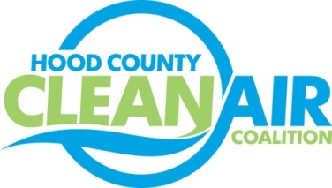
Meeting: Wednesday, September 5, 2018
Neely House
304 E. Rucker St. Granbury, Texas 76048
8:30-10:00 a.m.

Agenda

- Call Meeting to Order
- EPA Updates – Randy Pitre, EPA
- Local Updates – Michelle McKenzie
  - Review of July and August Meeting Summary
  - Review of Projects
    - Monthly Budget Review for June and July
    - Closeout of Rider 7
    - Status of Projects
  - Reports
    - August Ozone Update
    - DFW Clean Cities Biannual Meeting
    - Fleets for the Future Webinar: Incorporating Gaseous Fuel Vehicles into Your Fleet
    - Legislative Budget Board Hearing for TCEQ
- Regional Updates – Michelle McKenzie
  - Air North Texas Progress Reports due September 21
  - DFW Clean Cities Event: Autogas Answers on October 30
  - TCEQ Accepting Comments on Draft Mitigation Plan for Texas, www.TexasVWFund.org
  - Funding Opportunities: www.nctcog.org/aqfunding
    - State Rebate for EVs, Propane/ CNG Trucks, First-come, First-served
    - Oncor Service Territory Rebate for Nissan Leaf
- Other Discussion
- Adjourn

